DEALS TO QUEENS

Queens is a diverse New York borough with many great attractions. From being able to try various foods from around the world and seeing fascinating art, to watching Mets baseball and US Open tennis, you’ll love all that Queens has to offer. Book a trip to Queens via LaGuardia International, John F. Kennedy International Airport or Newark Liberty International Airport on Virgin America. Live it up at 35,000 feet with WiFi, on-demand entertainment, and more on every flight.

(MARKET IMAGE HERE)

Find Deals From These Cities

INSERT FARE GRID FROM / TO Version (if available!)



Top Things To Do in Queens

Try some of these top things to do in Queens when you visit.

* Spend a fun day at Flushing Meadows-Corona Park. The city’s second biggest park has a wide variety of wonderful things to see and do, including the New York Hall of Science, Arthur Ashe Stadium, Citi Field (catch a Mets game if you’re a baseball fan), a zoo, and much more. Take a picture of the Unisphere – a gigantic steel globe that was made for the 1964 World’s Fair.
* Have fun exploring the Museum of the Moving Image. This museum is one of the most dynamic establishments in the city and includes a three-story extension that features a state-of-the-art, 267-seat cinema. Be sure to check out the “Behind the Screen” exhibit to see every step of the filmmaking process up close. And play a game of Ms. Pac-Man or Space Invaders while you’re there!
* Visit The Noguchi Museum, designed and created by the Japanese-American sculptor Isamu Noguchi. Take one of the hour-long guided tours to learn more about the life and vision of this influential artist.

Travel Tips and Resources

[Must-Dos in Queens](http://www.tripadvisor.com/Attractions-g616325-Activities-Queens_New_York.html)

[Queens Hotels](http://www.tripadvisor.com/Hotels-g616325-Queens_New_York-Hotels.html)

[Queens Restaurants](http://www.timeout.com/newyork/food-drink/10-best-queens-restaurants)

[Queens Shopping Guidehttp://www.nydailynews.com/new-york/queens/best-boros-shopping-queens-article-1.176386](http://www.nydailynews.com/new-york/queens/best-boros-shopping-queens-article-1.176386)

[Queens Nightlife and Entertainmenthttp://www.nyctourist.com/queens-ny-nightlife](http://www.nyctourist.com/queens-ny-nightlife)

[Queens Travel Tipshttp://www.fodors.com/world/north-america/usa/new-york/new-york-city/neighborhoods/queens](http://www.fodors.com/world/north-america/usa/new-york/new-york-city/neighborhoods/queens)

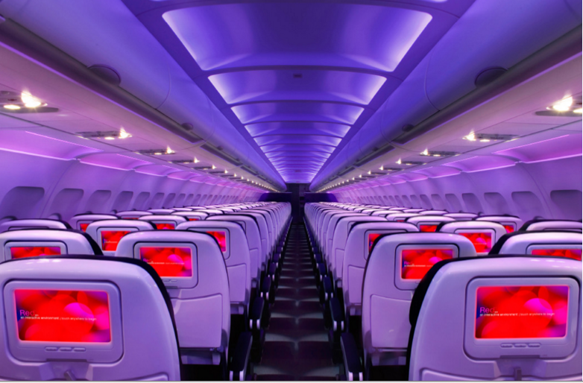

Main Cabin Main Cabin Select First Class

(add links to Cabin Class Pages)

Ready. Set. Fly.

Book your Mood-lit Ride to Queens.

When you’re visiting this city, book your flight with Virgin America to LaGuardia International, John F. Kennedy International Airport or Newark Liberty International Airport. When you fly with us, you’ll enjoy a leisurely trip from start to finish. Do custom-designed leather seats that provide maximum comfort appeal to you? How about being able to order food on demand, rather than waiting for a cart approach your seat? Would mood-lit cabins inspire you to sit back and relax for a bit? Then you’ll love experiencing all of this and more on our flights.

Take a Virtual Tour

Add Terms & Conditions